Fun with lists: indexOf

DESCRIPTION:
Implement the method indexOf (index_of in PHP), which accepts a linked list (head) and a value, and returns the index (zero based) of the first occurrence of that value if exists, or -1 otherwise.
For example: Given the list: 1 -> 2 -> 3 -> 3, and the value 3, indexOf / index_of should return 2.

SOLUTION:
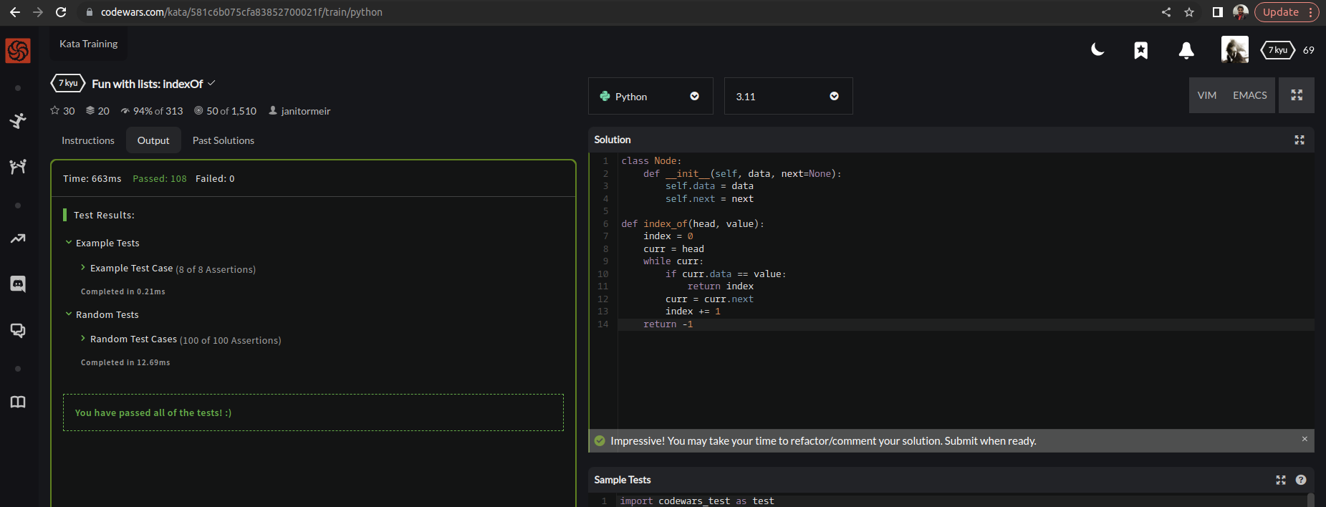

EXPLANATION:
This implementation defines a Node class to represent nodes in the linked list. The indexOf method takes a head parameter, which is the first node in the linked list, and a value parameter, which is the value to search for in the list. The method initializes an index variable to zero and a current variable to the head of the list. It then loops through the list, checking each node's data value for a match with the value parameter. If a match is found, the method returns the current index value. If no match is found, the method moves to the next node in the list and increments the index value. If the end of the list is reached without finding a match, the method returns -1 to indicate that the value was not found in the list.

